Yadhnika Wakde

DWBI Lab Practical 1

1.

1. Write a query to create range partioned table:
2. ➢ Creates a table named- Sales consisting of four partitions, one for each quarter of
3. sales. The column sale_date are the partitioning columns, while their values
4. constitute the partitioning key of a specific row.
5. ➢ Each partition is given a name (sales_q1, sales_q2, ...), and each partition is
6. contained in a separate tablespace (tsa, tsb, ...)
7. ➢ The columns for table must be prod_id, cust_id, promo_id, quantiy sold, amount_sold
8. – all in number format and sale_date.

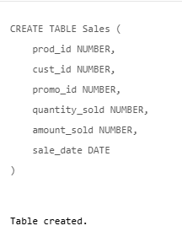

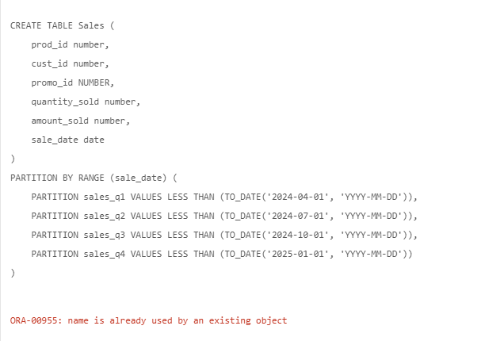

Error rectified by using a different table name, since the table name was already used.

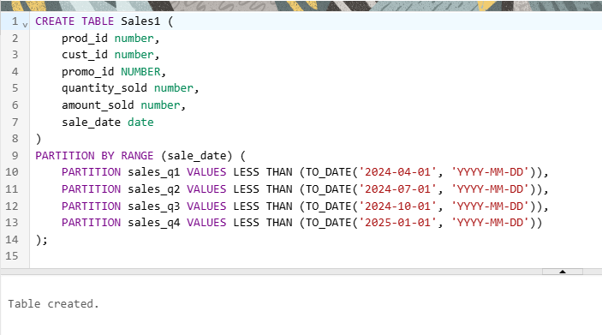

2. Create the same table as in Q1. With a different name with ENABLE ROW

MOVEMENT. Bring out the difference in these two tables.

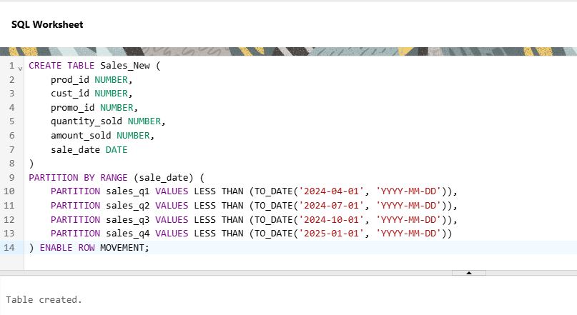

3. Create a table with list partition as follows:

➢ Table having columns deptno, deptname, quarterly_sales and state.

➢ Create partition on state:

• Northwest on OR and WA

• Southwest on AZ, UT and NM

• northeast on NY, VM and NJ

• southeast on FL and GA

• northcentral on SD and WI

• southcentral on OK and TX

➢ Add the following entries into the table and make conclusion to which partition the

entry maps:

• (10, &#39;accounting&#39;, 100, &#39;WA&#39;)

• (20, &#39;R&amp;D&#39;, 150, &#39;OR&#39;)

• (30, &#39;sales&#39;, 100, &#39;FL&#39;)

• (40, &#39;HR&#39;, 10, &#39;TX&#39;)

• (50, &#39;systems engineering&#39;, 10, &#39;CA&#39;)

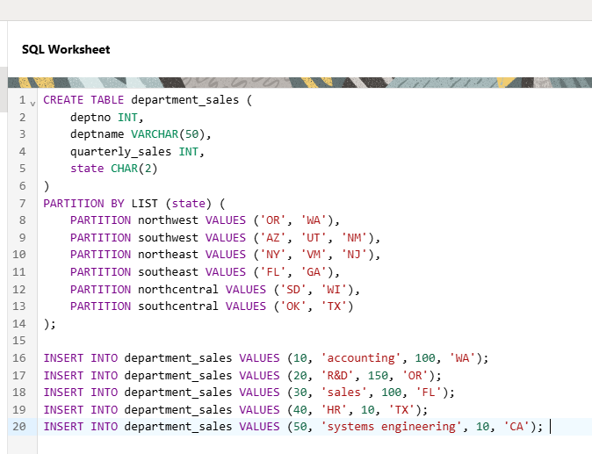

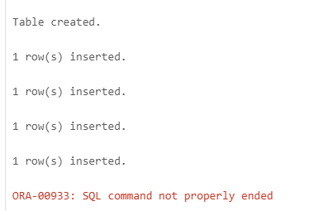

4. Create a multi-column range partitioned table as directed:

➢ Create a table with the actual DATE information in three separate columns: year,

month, and day. Also amount_ sold.

➢ Create following partitions:

• Before 2001: Less than jan 2001

• Less than april 2001

• Less than july 2001

• Less than oct 2001

• Less than jan 2002

• Future with max incoming value

➢ Insert values into table and show to which partition does the value belong.

• (2001,3,17, 2000);

• (2001,11,1, 5000);

• (2002,1,1, 4000);

Make conclusion for each result.

